

Project Name:
Qatma
Prepared by:
Retaj Ali 231005689
Mohanad Waleed 231005430
Rawan Atef 231005789
Doha Mahmoud 231005333

Instructor: | Dr. Mohamed Osama Khozium
Course: | Designing Human Centered Software
Teaching Assistant: | ENG. Fathy Mohamed
Date: | 16/04//2026

AGENDA
Contents

1. Introduction 1

2. Problem Definition 1

3. Project Objectives 1

4. Data Gathering 2

5. User Requirements 3
6. Similar Applications & UI/UX Problems 4

7. Conceptual Model 5
8. Mood Board 6
9. Personas 7

10. Identity Branding 8

11. Site Map 9

12. User Flow 10

13. Figma Design 11

Introduction
Qatma is a mobile application designed to make food ordering easy and convenient for users. In today’s fast-paced life, people often do not have enough time to visit restaurants or wait for long ordering processes. Many existing methods can be confusing, slow, and not user-friendly.
This application provides a simple and clear platform where users can browse restaurants, view menus, select their meals, and place orders quickly. It also allows users to track their orders, choose payment methods, and manage their profiles easily.
Qatma focuses on improving the overall user experience by offering a clean interface, easy navigation, and fast performance. The goal is to make food ordering faster, easier, and more enjoyable for everyone.

Problem Definition
The current food ordering process has many problems. Users may find it difficult to browse menus, place orders, and know the status of their orders. Some applications are complicated and not easy to use.
Users also may not have enough information about restaurants, such as reviews and delivery time. This makes the experience confusing and slow.
For restaurants, managing orders can be difficult and may lead to delays or mistakes.
Because of these issues, there is a need for a simple and easy-to-use application that makes food ordering faster and more convenient.
Project Objectives
- Simplify Ordering Process:
• Develop an easy-to-use interface for browsing restaurants and placing orders.
• Ensure a smooth and fast ordering process with clear steps.
- Enhance User Experience:
• Provide a clean and simple design for easy navigation.
• Allow users to view menus, prices, and food details clearly.
- Efficient Order Management:
• Enable users to add items to cart and manage their orders easily.
• Show order summary with total price and details before checkout.
- Facilitate Communication:
• Provide order status updates and notifications.
• Allow users to track their orders in real-time.
- Support Multiple Payment Options:
• Offer different payment methods such as cash and card.
• Ensure a simple and secure payment process.
- Promote User Engagement:
• Allow users to save favorite items and addresses.
• Provide a user profile to manage orders and personal information.

Data Gathering (Qatma Form)
Survey Questions & Answers
- How often do you order food online?
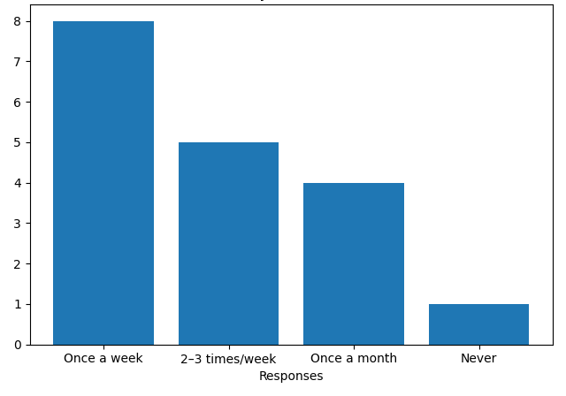
- Which features are essential in a food delivery app?
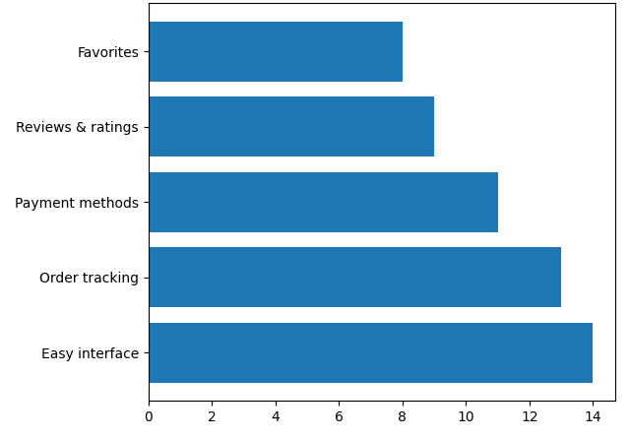

- How important is real-time order tracking?
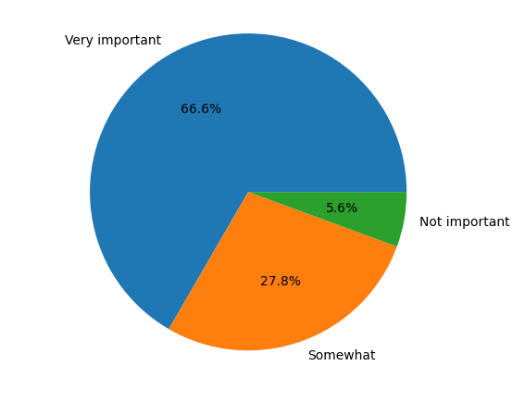
- How likely are you to use an app instead of calling?
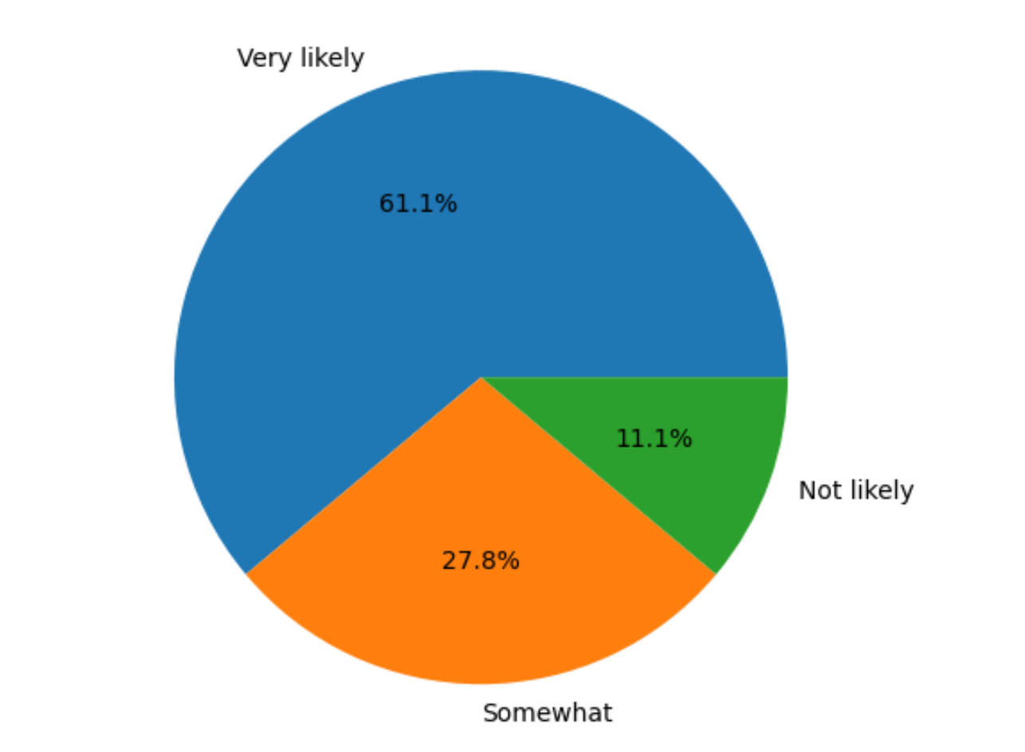
- Do you prefer meal customization?
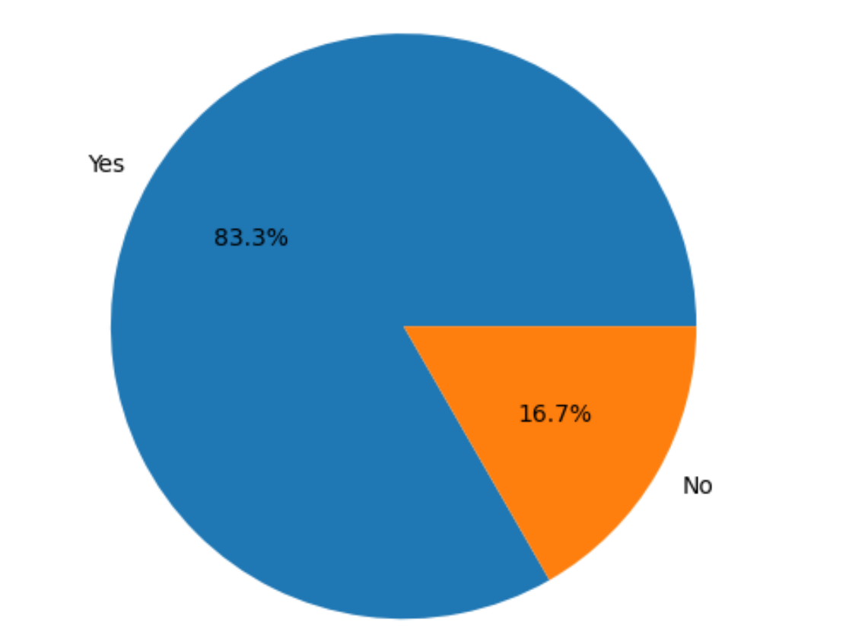
- Which payment method do you prefer?
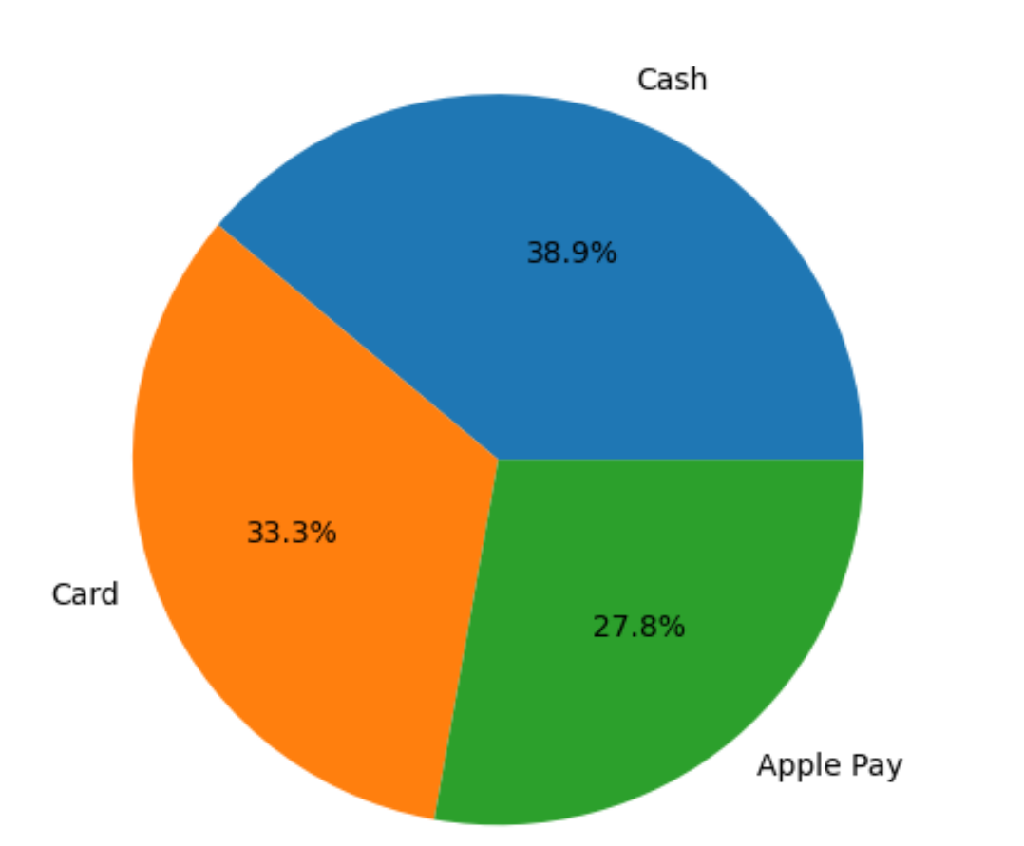
- What delivery time do you expect?
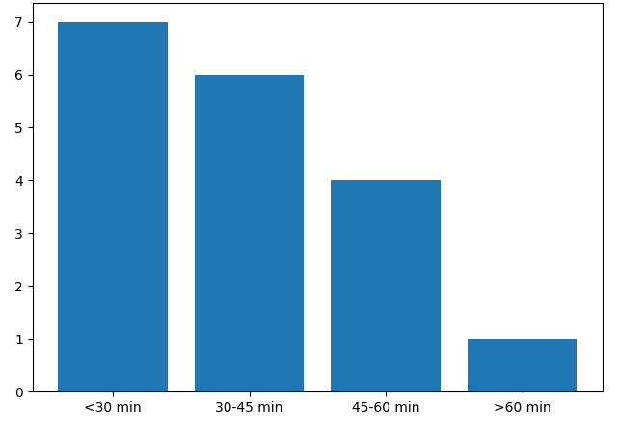
- How important is app design (UI/UX)?
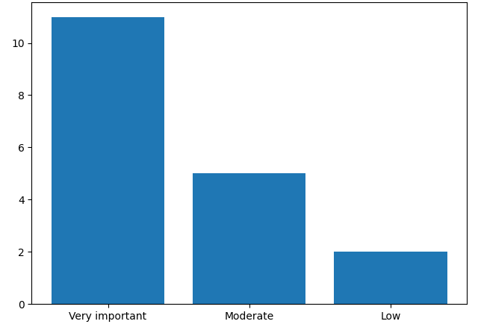
User Requirements
- Easy Ordering Process:
• Users should be able to easily browse restaurants and select meals through a simple interface.
• The app should provide a clear and fast process for placing orders without confusion.
- Personalized Experience:
• Users should be able to customize their orders.
• Access to menus, prices, and food details should help users make better decisions.
- Efficient Cart Management:
• Users should be able to add, remove, and update items in the cart easily.
• The app should display the total price and order details clearly before checkout.
- Order Tracking and Notifications:
• Users should be able to track their orders in real-time.
• The app should send notifications about order status and delivery updates.
- Flexible Payment Options:
• Users should be able to choose between different payment methods.
• The payment process should be simple and secure.
- User Account Management:
• Users should be able to create accounts, log in, and manage their profiles.
• The app should allow users to save addresses and view order history.

Similar Applications & UI/UX Problems
- Talabat – UI/UX Problems:
- Cluttered interface with too many options, making it difficult for users to find what they want quickly.
- Slow navigation between screens, which affects the user experience during ordering.
Solution in Our App:
- Qatma provides a clean and simple interface that makes browsing restaurants and menus easy.
- Fast and smooth navigation allows users to complete their orders quickly without confusion.

- Uber Eats – UI/UX Problems:
- The ordering process can be long with multiple steps, which may confuse users.
- Limited clarity in order tracking and delivery updates at some stages.
Solution in Our App:
- Qatma simplifies the ordering process with clear steps from selecting items to checkout.
- Real-time tracking and clear notifications keep users always updated about their orders.
Conceptual Model
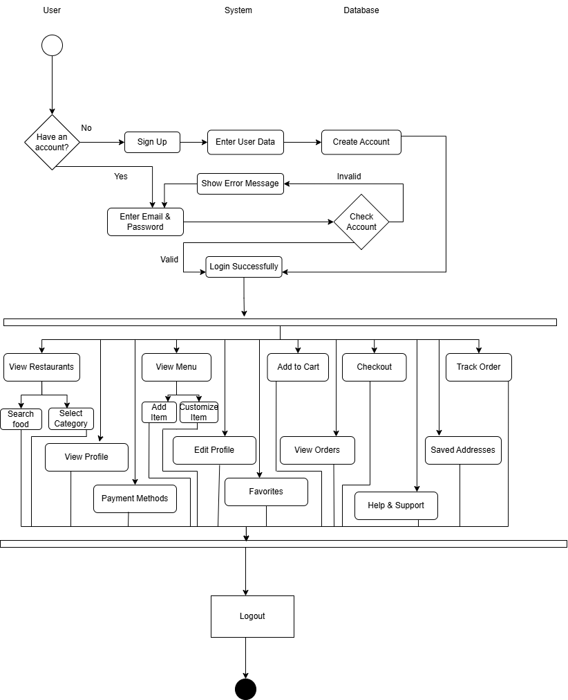
MoodBoard
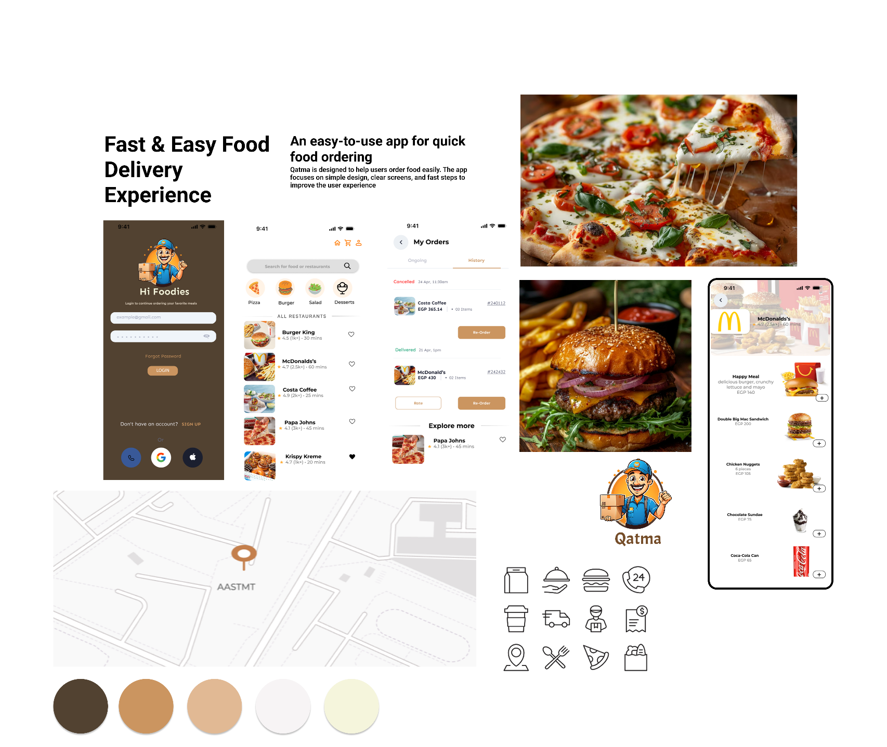

Personas
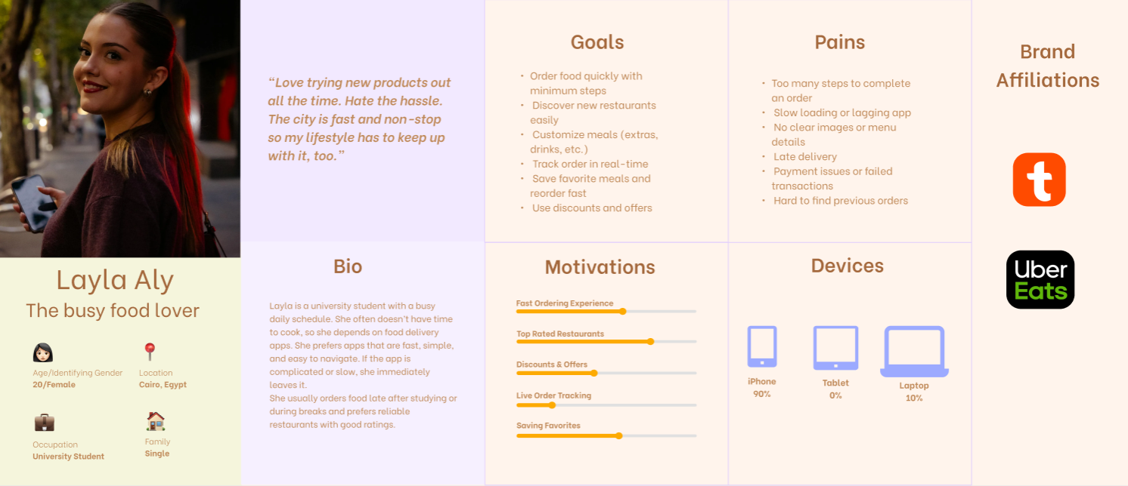
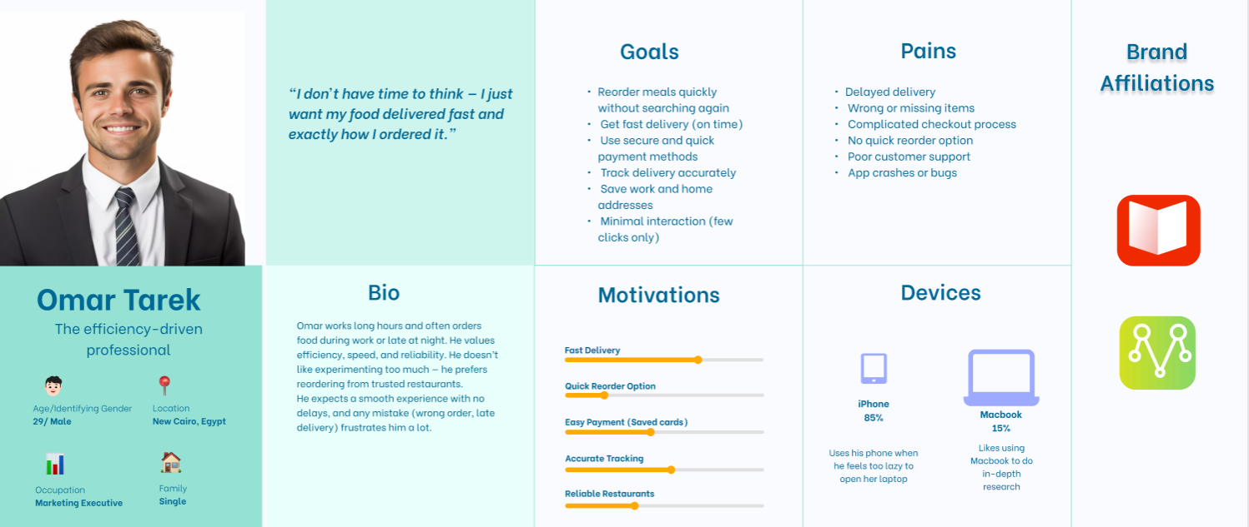

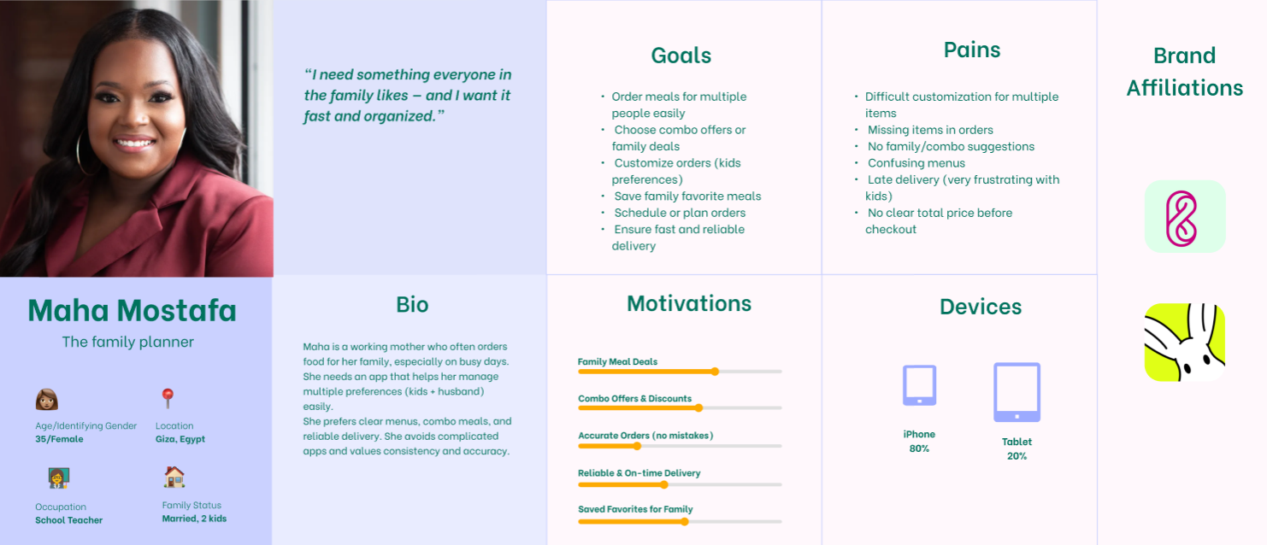
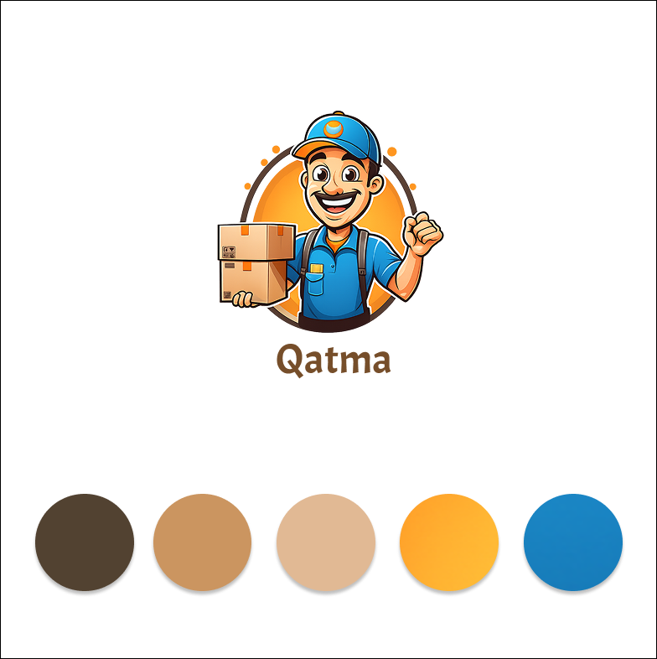
Identity Branding

Site Map
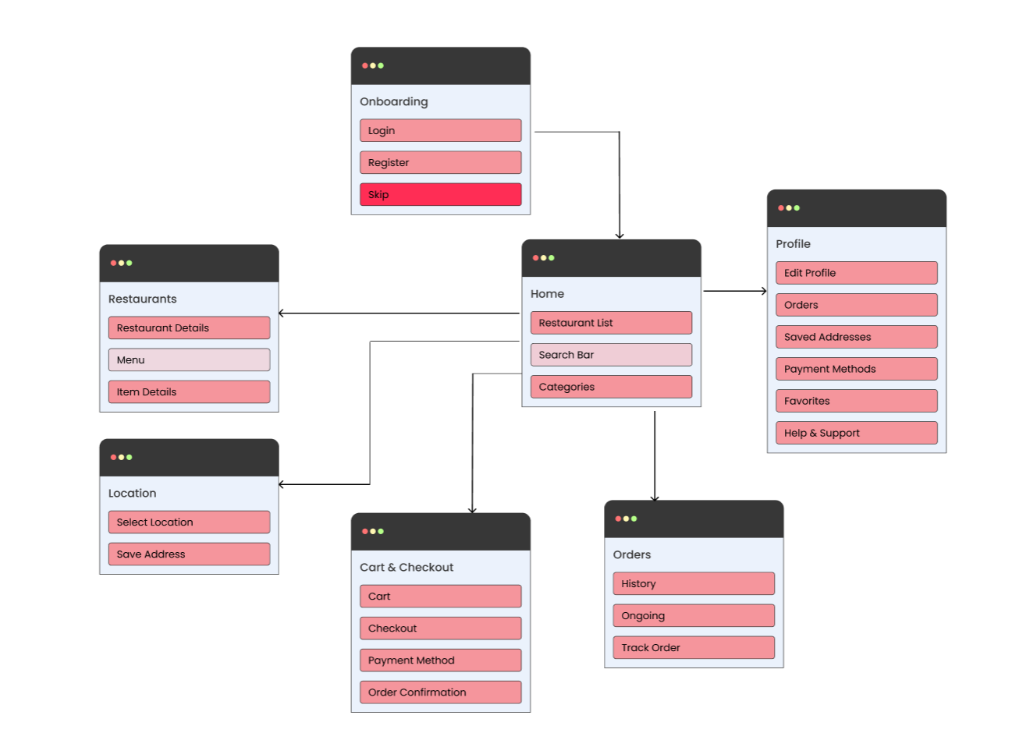

User Flow
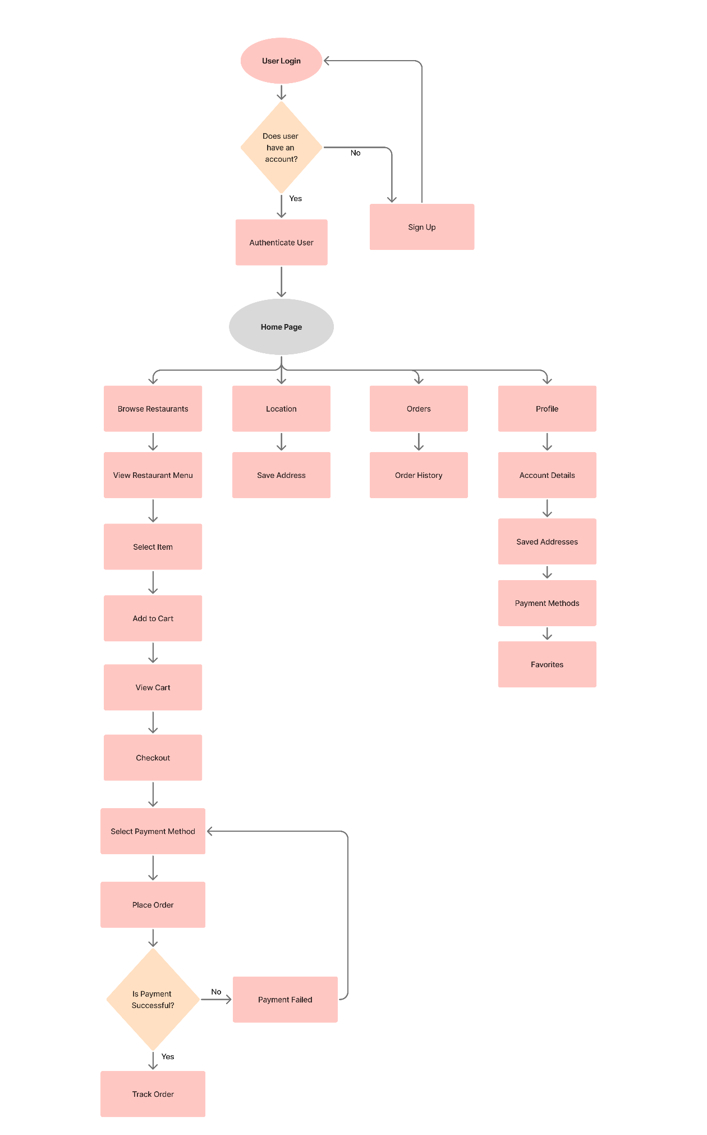
Qatma Figma Design
https://www.figma.com/design/O8RxHinL39cEy07taeBMmQ/Qatma-Food-Delivery-App?node-id=0-1&t=iqwFCCwzewRscTeK-1

